Retail Superstore Data Analysis

Step 1 — Data Preparation & Understanding
(Sheet Orders)
1. Columns check
- Order ID
- Order Date
- Ship Date
- Ship Mode
- Customer ID
- Customer Name
- Segment
- Country
- City
- State
- Postal Code
- Region
- Product ID
- Category
- Sub-Category
- Product Name
- Sales
- Quantity
- Discount
- Profit
2. convert Data into Table
Ctrl + A → Ctrl + T
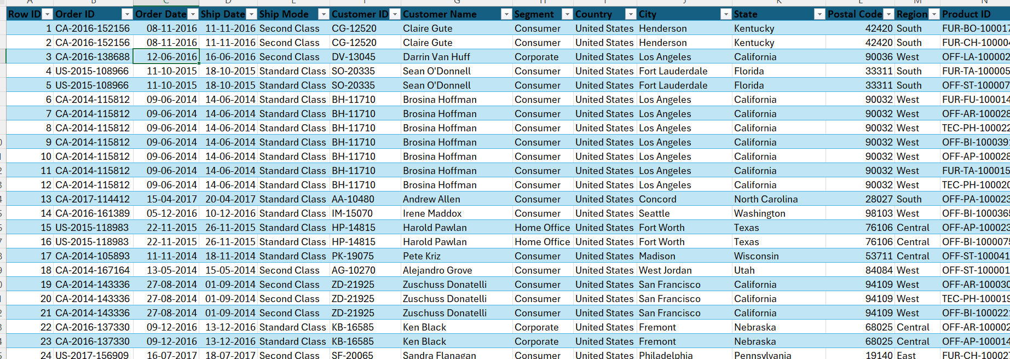
After removing all duplicates
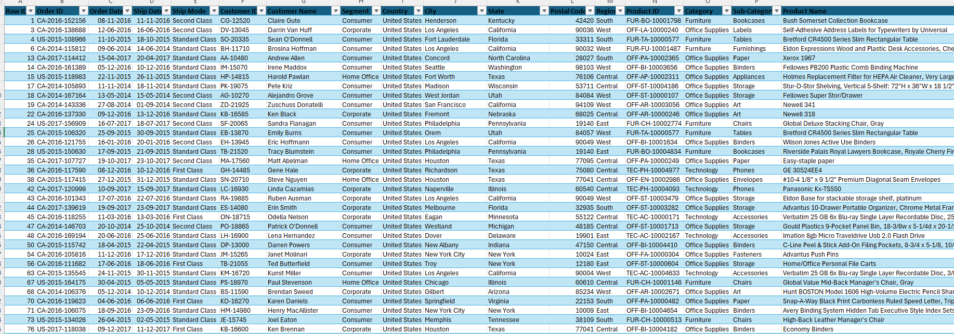
After that
Table name – tblOrders
3. Basic data-quality checks
Count Order IDs:
=COUNTA(tblOrders[Order ID])
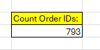
Missing Order IDs:
=COUNTBLANK(tblOrders[Order ID])
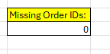
Missing Customer IDs:
=COUNTBLANK(tblOrders[Customer ID])
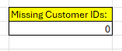
Missing Sales:
=COUNTBLANK(tblOrders[Sales])
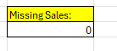
Missing Profit:
=COUNTBLANK(tblOrders[Profit])
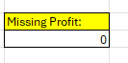
4. Negative Profit check
=COUNTIF(tblOrders[Profit],"<0")
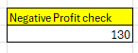
5. Date format
Order Date and Ship Date convert into proper Date format
Home → Number Format → Short Date

Step 2 — Text Functions
(Sheet text functions)
- UPPER
=UPPER(A2)
# disha gupta → DISHA GUPTA
- LOWER
=LOWER(A2)
# DISHA GUPTA → disha Gupta
- PROPER
=PROPER(A2)
# disha gupta → Disha Gupta
- LEFT
=LEFT(A2,5)
# Disha Gupta → Disha
- RIGHT
=RIGHT(A2,5)
# Disha Gupta → Gupta
- FIND
=FIND(" ",A2)
# Disha Gupta → 6
- FIND + LEFT
=LEFT(A2,FIND(" ",A2)-1)
# Disha
- FIND + RIGHT
=RIGHT(A2,LEN(A2)-FIND(" ",A2))
# Gupta
- LEN
=LEN(A2)
# 11
Result:
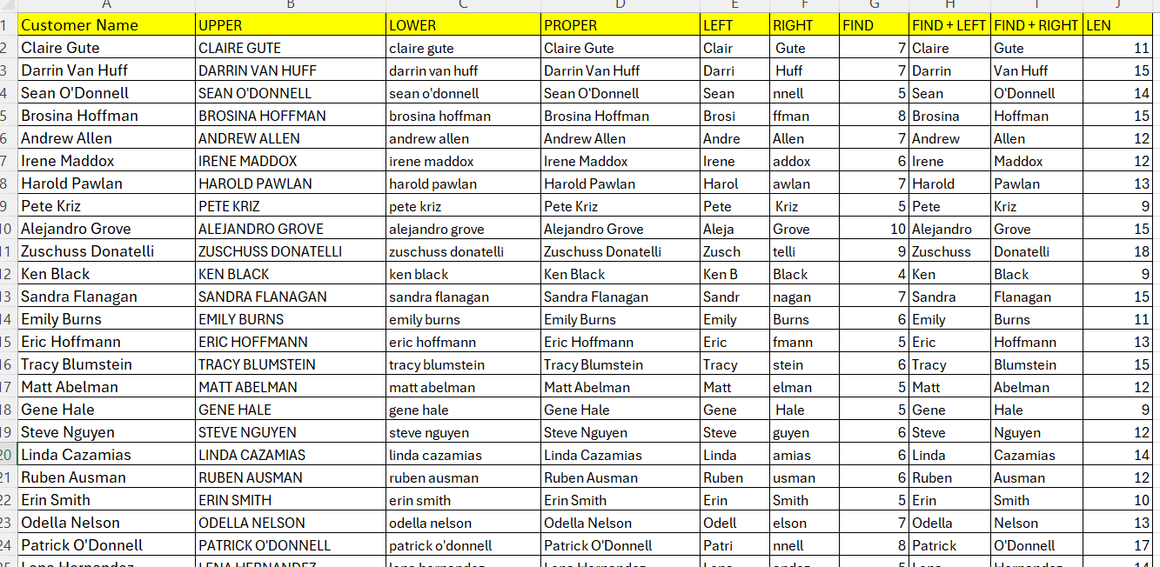

Step 3 — Basic Sales & Profit Analysis
(Sheet Basic Analysis)
Total Sales
=SUM(tblOrders[Sales])
Total Profit
=SUM(tblOrders[Profit])
Total Quantity
=SUM(tblOrders[Quantity])
Average Discount
=AVERAGE(tblOrders[Discount])

Step 3 — Product & Category
(sheet Product & Category Performance)

Step 4 — Customer & Segment
(sheet Customer & Segment Insights)

Step 5 — Time & Trend
(sheet Time & Trend Analysis)

Step 6 → Discount vs Profit
(sheet Discount & Profit Relationship)

Step 7 → Return Analysis
(Sheet Return Analysis)

Step 8 → Copilot Insights
(Sheet AI-Driven Insights Using Excel)

1.Dataset Summary
Copilot prompt:
Summarize this dataset and tell me key insights about sales and profit.
#
📊 Typical Dataset Structure
- Sales Data: Transaction-level records with product categories, subcategories, regions, and customer segments.
- Profit Data: Margins per product, discounts applied, and profitability by region or category.
- Time Dimension: Order dates, shipping dates, seasonal trends.
- Geography: Regional or city-level breakdowns.
🔑 Key Insights You’d Likely See
- Top Performing Categories: Furniture, Office Supplies, and Technology often show different sales/profit dynamics. For example, Technology may drive high sales but lower margins due to discounts.
- Regional Trends: Certain regions (like the West in U.S. datasets) tend to outperform others in both sales and profit, while others may show high sales but low profitability.
- Discount Impact: Heavy discounts usually boost sales volume but erode profit margins. Identifying the “sweet spot” for discounting is critical.
- Customer Segments: Corporate customers often generate steady profits, while consumer segments may be more price-sensitive.
- Seasonality: End-of-year months (November–December) often show spikes in sales, but profitability depends on discount strategies.
- Profitability Drivers: Some subcategories (like binders or tables) may consistently show negative profit despite strong sales, signaling a need for pricing or sourcing adjustments.
🚀 Actionable Takeaways
- Focus marketing and inventory on high-profit categories rather than just high sales.
- Reevaluate discount strategies for products that sell well but lose money.
- Strengthen presence in regions with high profitability and investigate causes of underperformance elsewhere.
- Use customer segmentation to tailor promotions—corporate vs. consumer vs. home office.

2. Regional & Category Performance PivotTable
Copilot prompt:
Create a pivot table showing Sales and Profit by Region and Category.
#
🛠 Steps to Create the Pivot Table
- Insert Pivot Table
  - Select your dataset.
  - Go to Insert → PivotTable.
  - Place it in a new worksheet for clarity.
- Set Up Fields
  - Rows: Drag Region and then Category.
  - Values: Drag Sales and Profit.
    - Ensure both are set to Sum (not Count).
  - (Optional) Add Sub-Category under Category for deeper detail.
- Formatting
  - Apply Number Formatting (Currency for Sales/Profit).
  - Use Conditional Formatting to highlight negative profits.
#
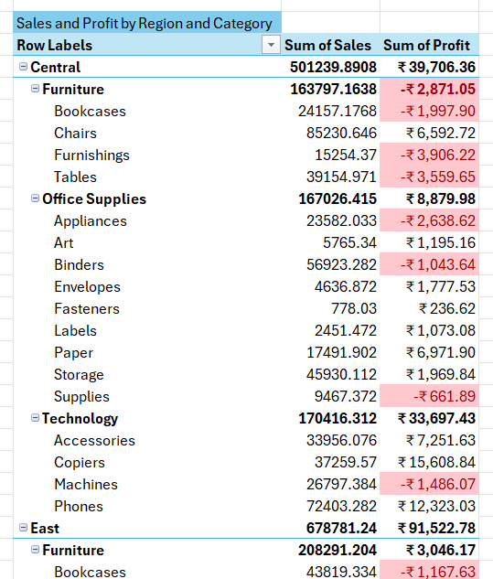

3.Monthly Sales Trend
Copilot prompt:
Show me the monthly sales trend with a chart.
#
Steps to Create the Chart
- Prepare Data
  - Ensure your dataset has an Order Date column.
  - Create a Pivot Table:
    - Rows: Drag Order Date (group by Months).
    - Values: Drag Sales (set to Sum).
- Insert Chart
  - With the pivot table selected, go to Insert → Line Chart (or Column Chart if you prefer).
  - This will plot Monthly Sales across the timeline.
- Format
  - Add Data Labels for clarity.
  - Use a Trendline to highlight overall growth/decline.
  - Apply Month-Year formatting on the axis for readability.
🔑 Insights
- Seasonality: End-of-year months usually show the highest sales.
- Growth Trend: A line chart makes it easy to spot whether sales are consistently rising or fluctuating.
- Forecasting: You can extend the trendline to estimate future sales.
#
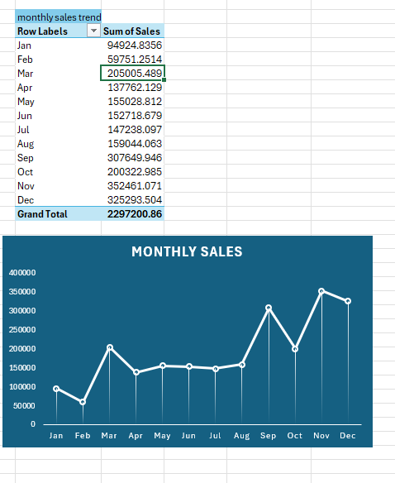

4.Loss-Making Products & Sub-Categories
Copilot prompt:
Which products and sub-categories are causing losses?
#
📉 Common Loss-Making Sub-Categories
- Furniture
  - Tables: Frequently show high sales but negative profit due to heavy discounts and high shipping costs.
  - Bookcases: Another sub-category with consistent losses, often linked to pricing and logistics.
- Office Supplies
  - Binders: A classic example of a product that sells in volume but erodes margins.
- Technology
  - Copiers: Sometimes sold at steep discounts, leading to losses despite large ticket sizes.
🔎 Why These Losses Occur
- Discounting Strategy: Deep discounts boost sales but cut into profit margins.
- Shipping Costs: Large items (like furniture) incur high delivery expenses.
- Pricing Issues: Some products are priced too aggressively to compete, resulting in negative margins.
- Supplier Contracts: Certain categories may have unfavorable sourcing costs.
🚀 What You Can Do
- Reevaluate discount policies for loss-making products.
- Consider bundling strategies (e.g., profitable accessories with low-margin items).
- Negotiate better supplier terms for categories like Furniture.
- Use profitability dashboards to monitor sub-category performance monthly.

Discount vs Profit
Copilot prompt:
Analyze how discount impacts profit and identify risky discount levels.
📊 Discount vs. Profit Relationship
- Low Discounts (0–20%)
  - Usually safe: sales increase modestly, and profit margins remain positive.
  - Best balance between volume and profitability.
- Moderate Discounts (20–40%)
  - Mixed results: sales volume rises sharply, but profit margins start to erode.
  - Some categories (like Technology) can still sustain profits, while Furniture often slips into losses.
- High Discounts (40%+)
  - Risk zone: sales spike, but profit often turns negative.
  - Sub-categories like Tables, Bookcases, and Binders are especially vulnerable here.
  - Large-ticket items (Furniture, Copiers) suffer the most because shipping and cost structures don’t scale down with discounts.
🔎 How to Identify Risky Discount Levels in Your Dataset
- Create a Pivot Table
  - Rows: Discount (grouped into ranges: 0–20%, 20–40%, 40%+).
  - Values: Sum of Profit.
  - Optional: Add Category/Sub-Category to see which products are most affected.
- Insert a Scatter Plot
  - X-axis: Discount %
  - Y-axis: Profit
  - This will show the tipping point where profit turns negative.
- Look for Thresholds
  - Identify the discount percentage where profit consistently drops below zero.
  - In most superstore datasets, this threshold is around 30–35%.
🚨 Actionable Insights
- Avoid offering >40% discounts on Furniture and Office Supplies.
- Use targeted promotions (e.g., 10–20%) for Technology, which can handle moderate discounts better.
- Monitor profit margin dashboards monthly to catch categories slipping into loss territory.
- Consider bundling or offering value-add promotions instead of steep discounts.
#
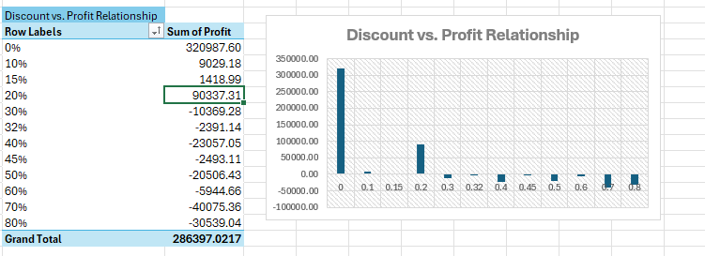

Step 9 — Final Dashboard
(Sheet Dashboard)
